Practical 5

Step 1: Open Wireshark

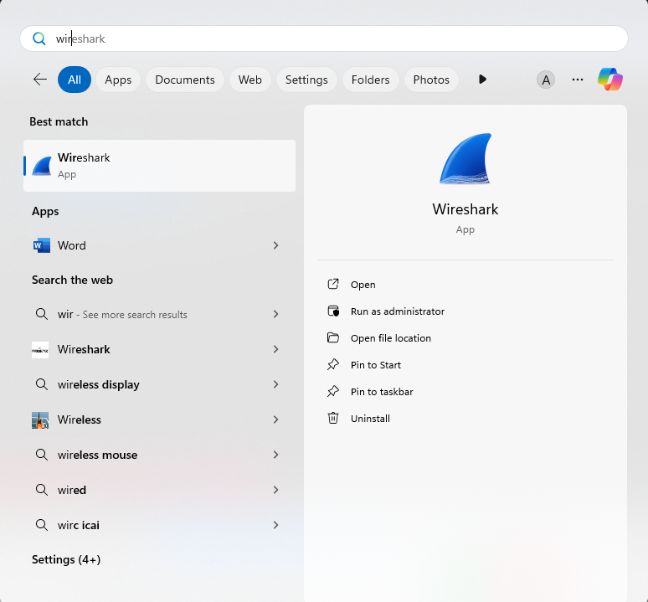

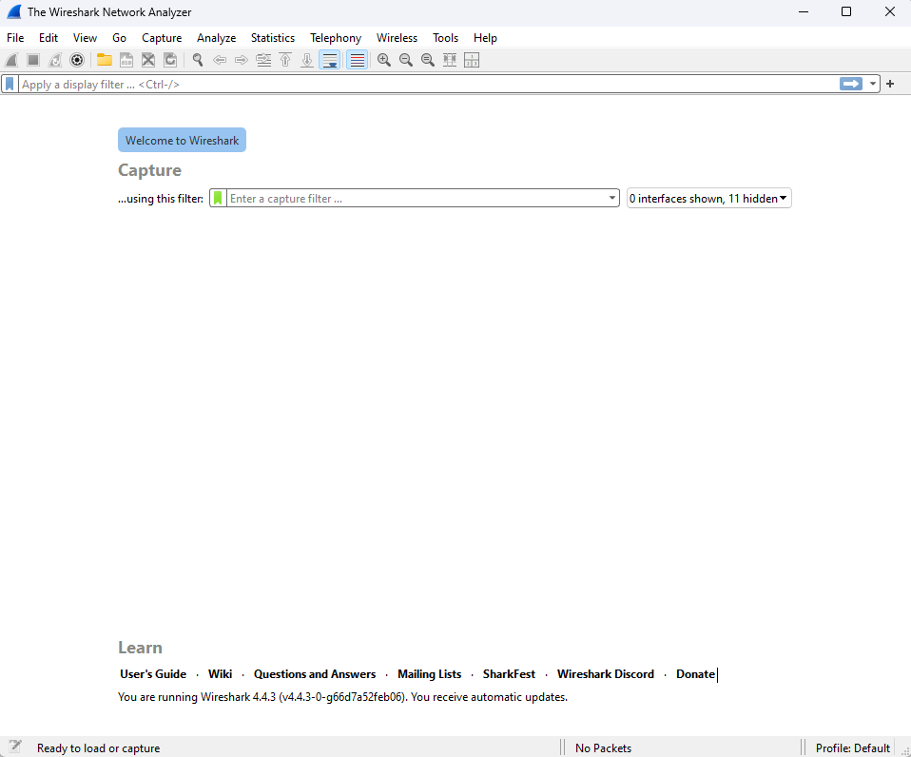

Step 2: Go to capture and option and select your connection

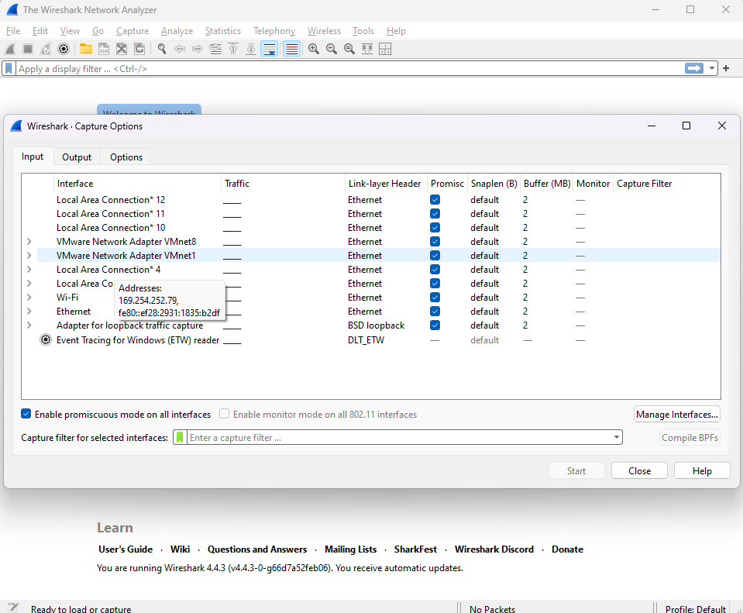

Step 3: Wireshark will start recording

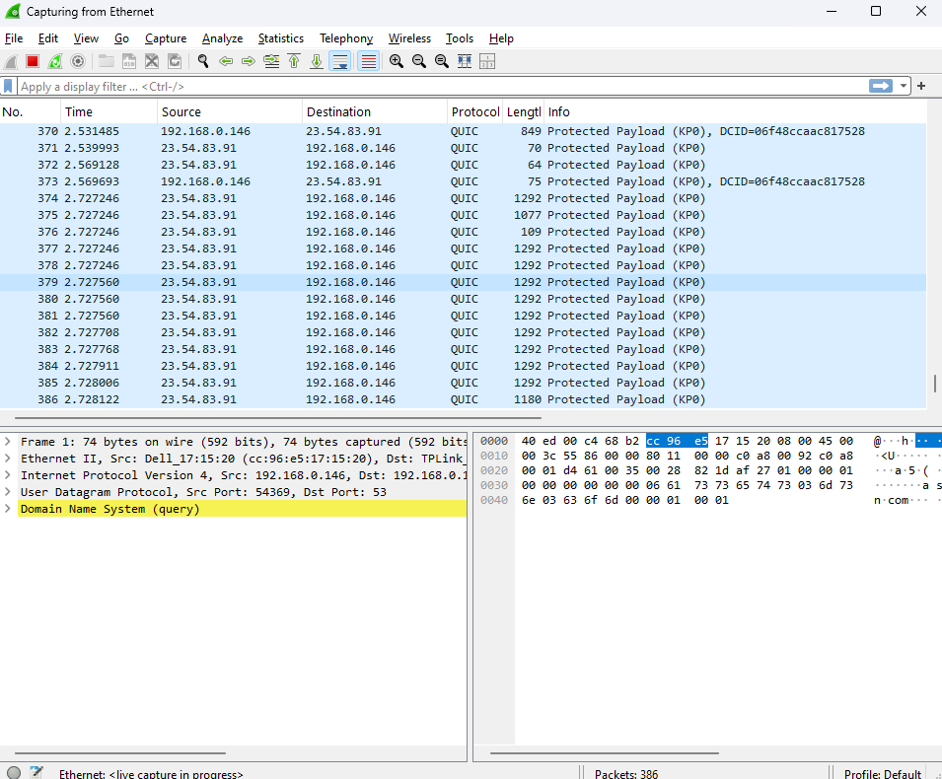

Step 4: Open a website in a new window and enter username and password, register if needed

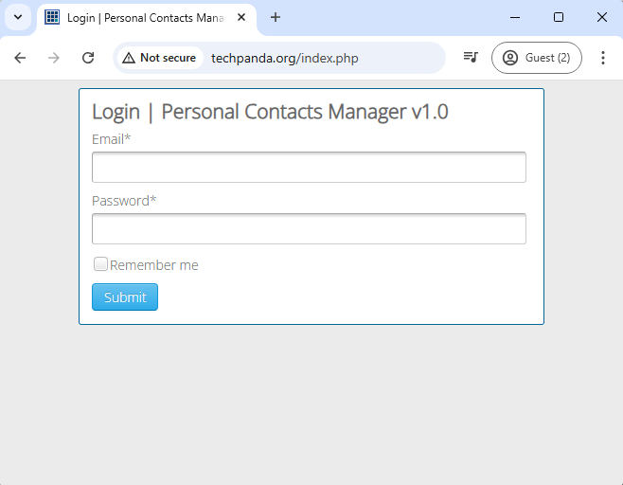

Step 5: Enter the details and sign in

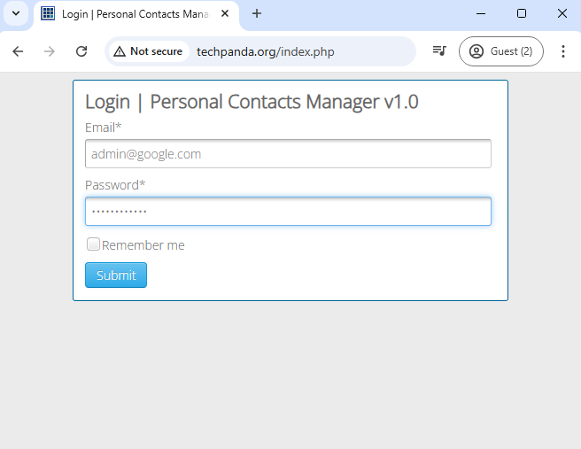

Step 6: The Wireshark tool will keep recording the packets

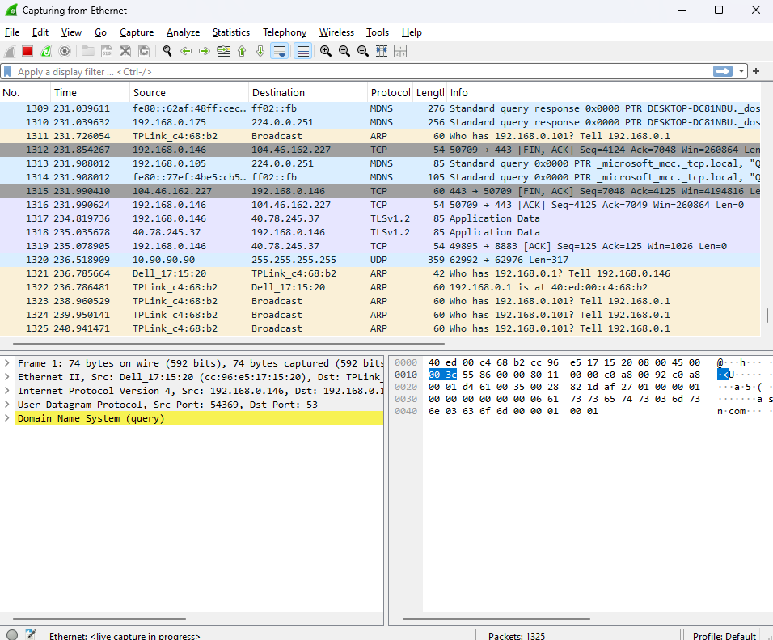

Step 7: Select filter as http to make the search easier and click on apply

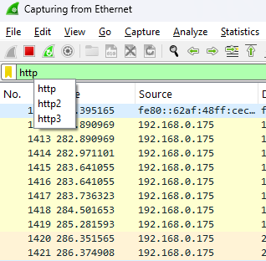

Step 8: Now stop the tool to stop recording

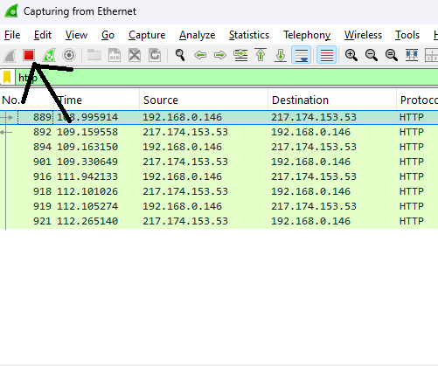

Step 9: Find the POST method for username and password

